**App Service Outbound Static Ip**

* Create Standard Web App

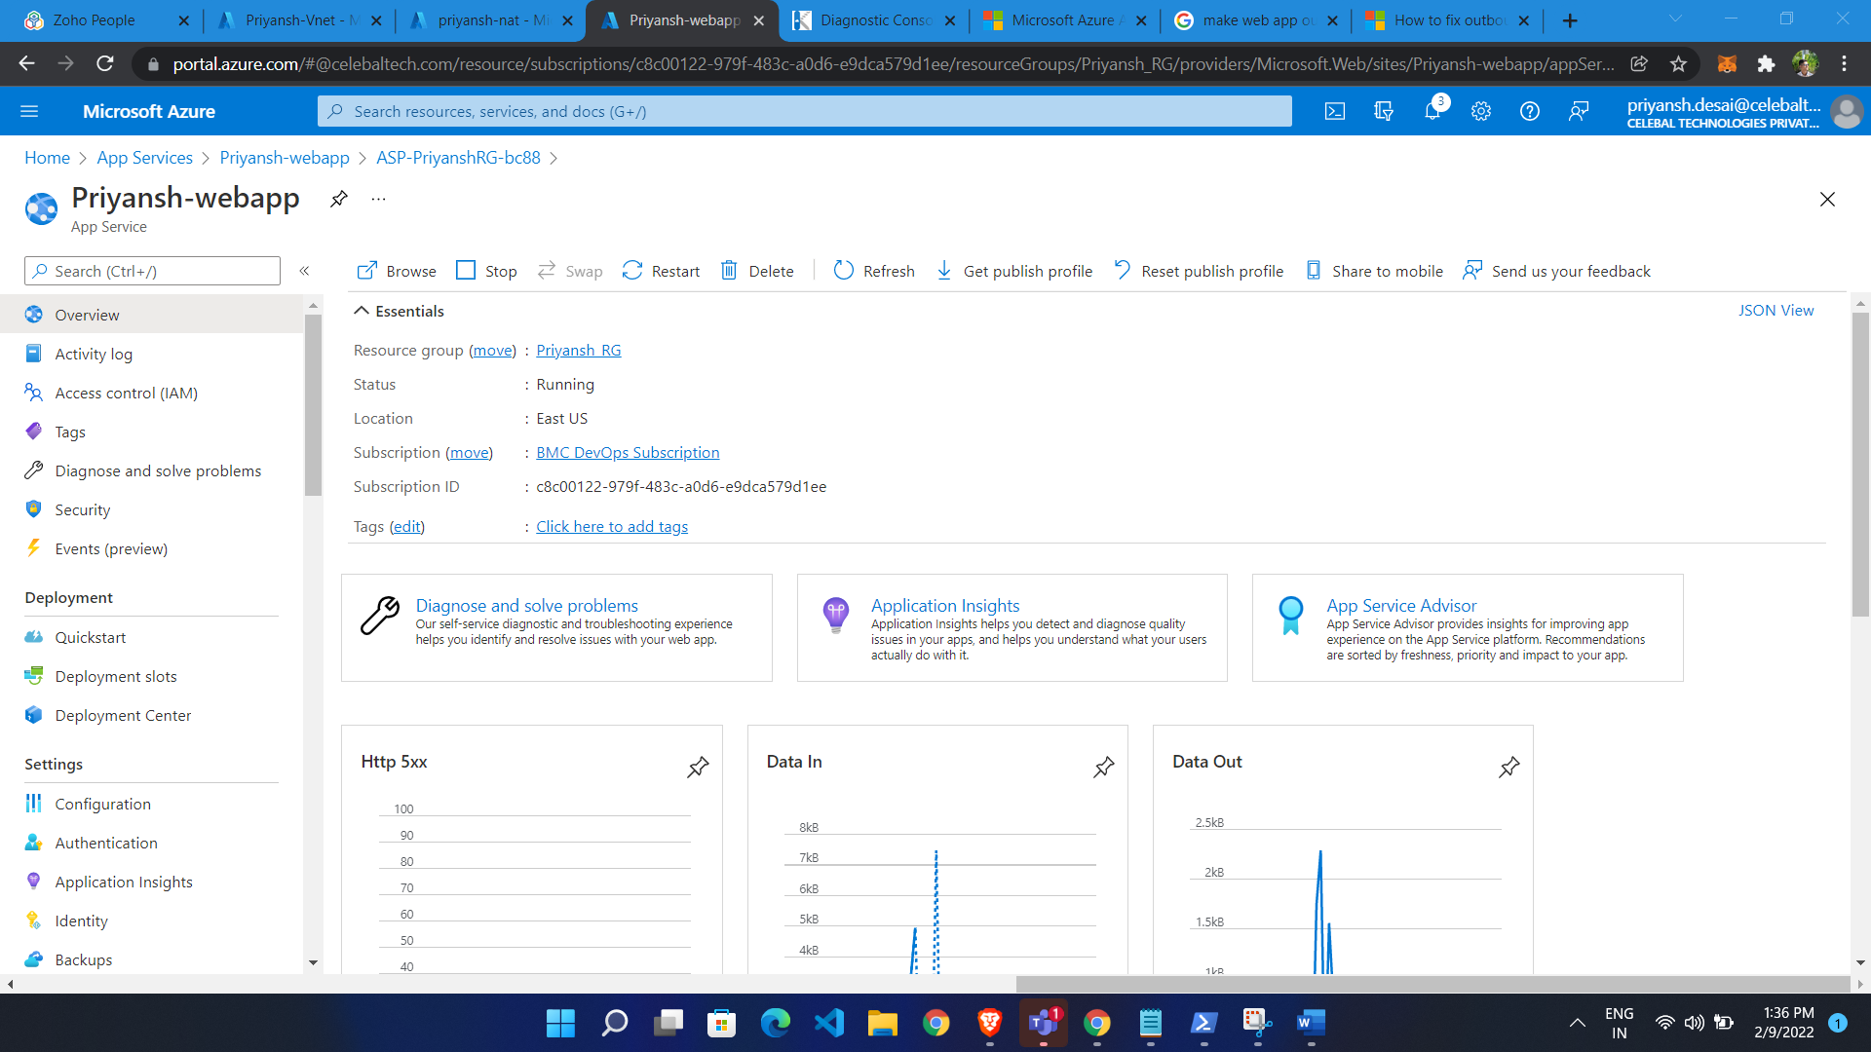

Create Vnet

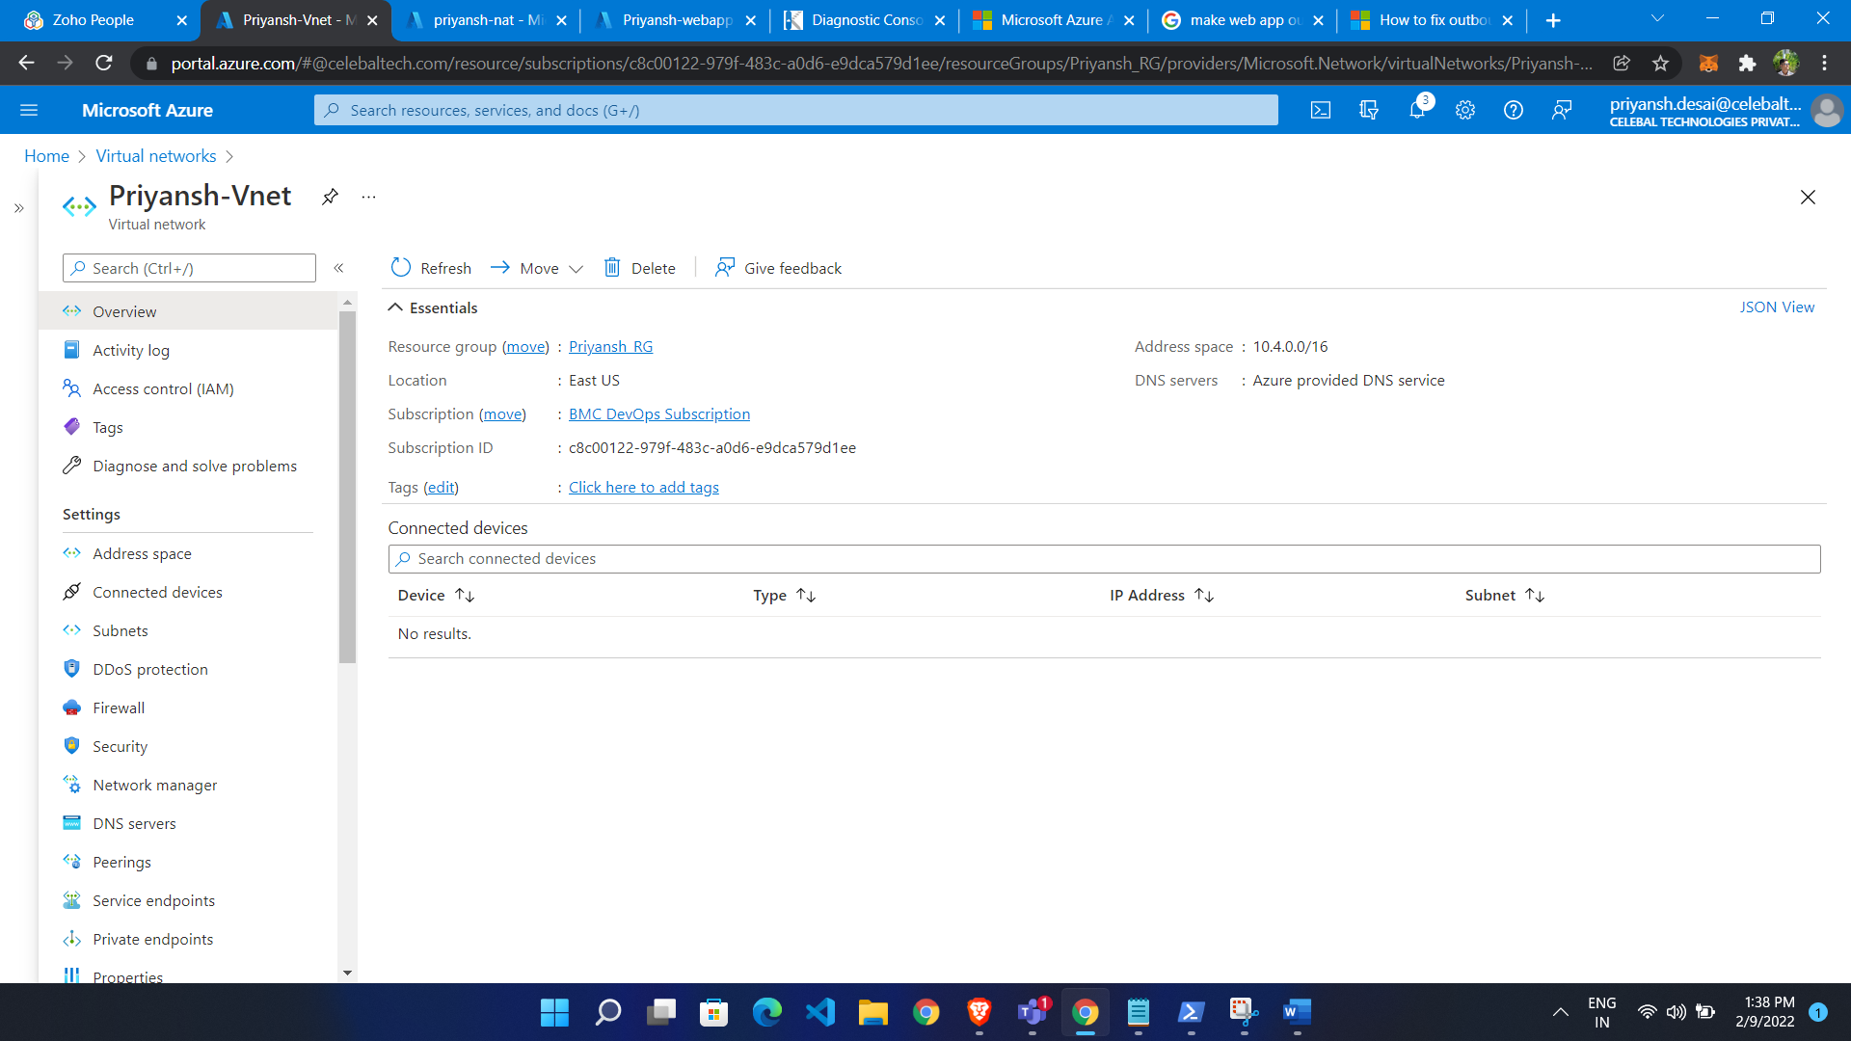

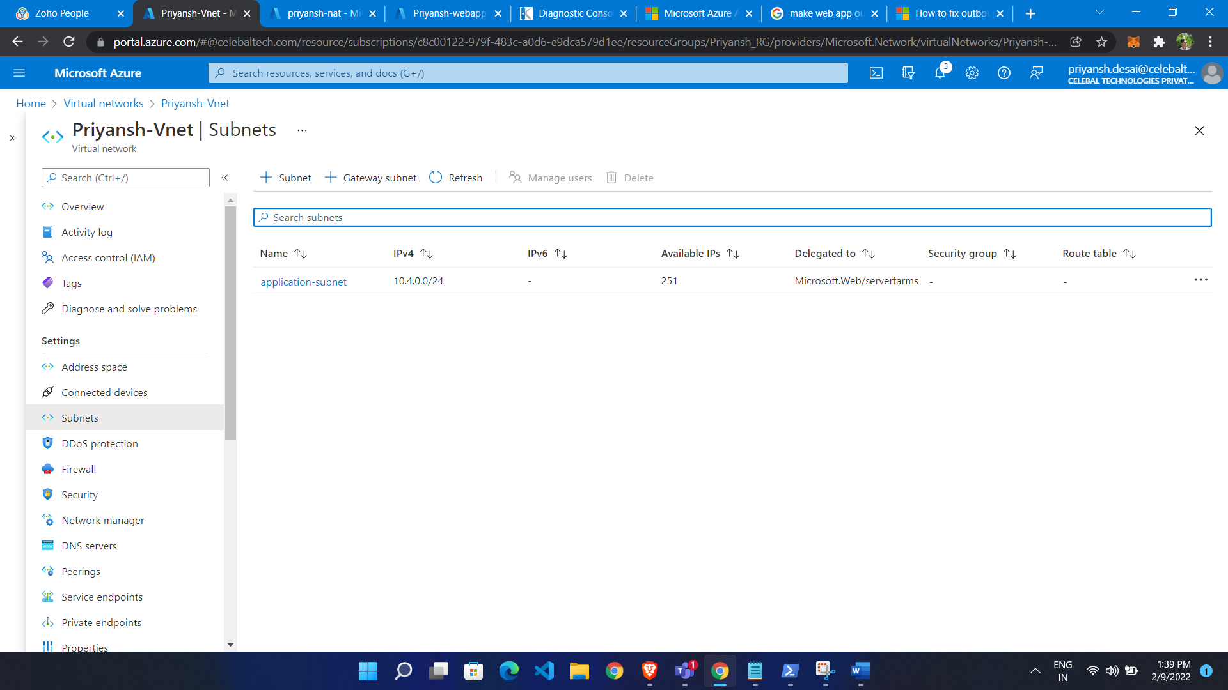

* Search for network gateway
* Click create
* Give name

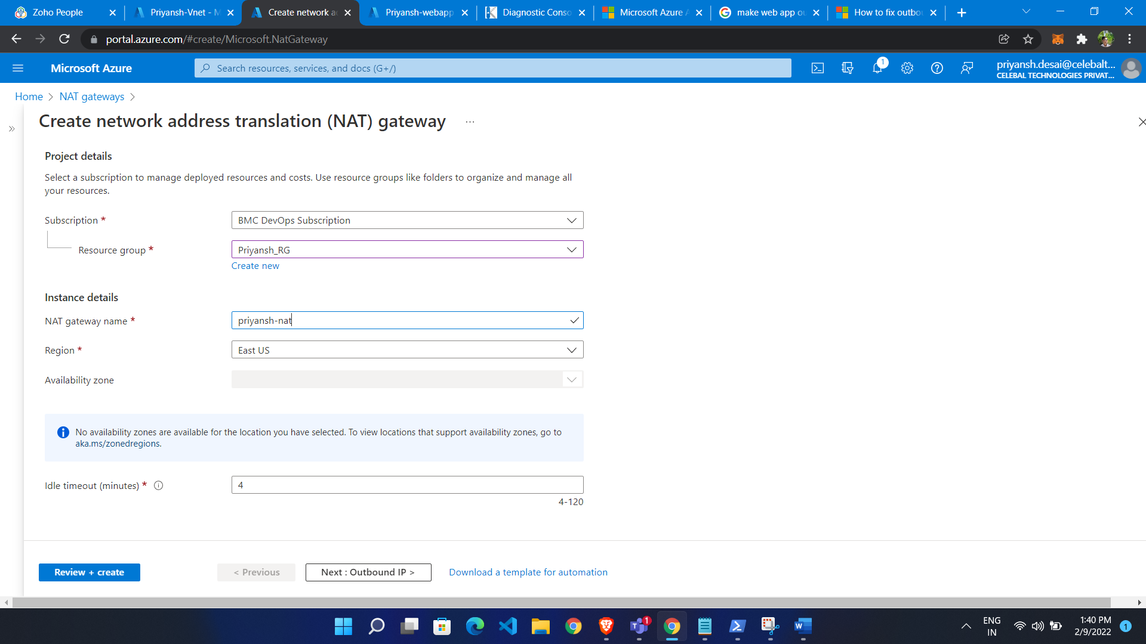

Add Public Ip to NAT

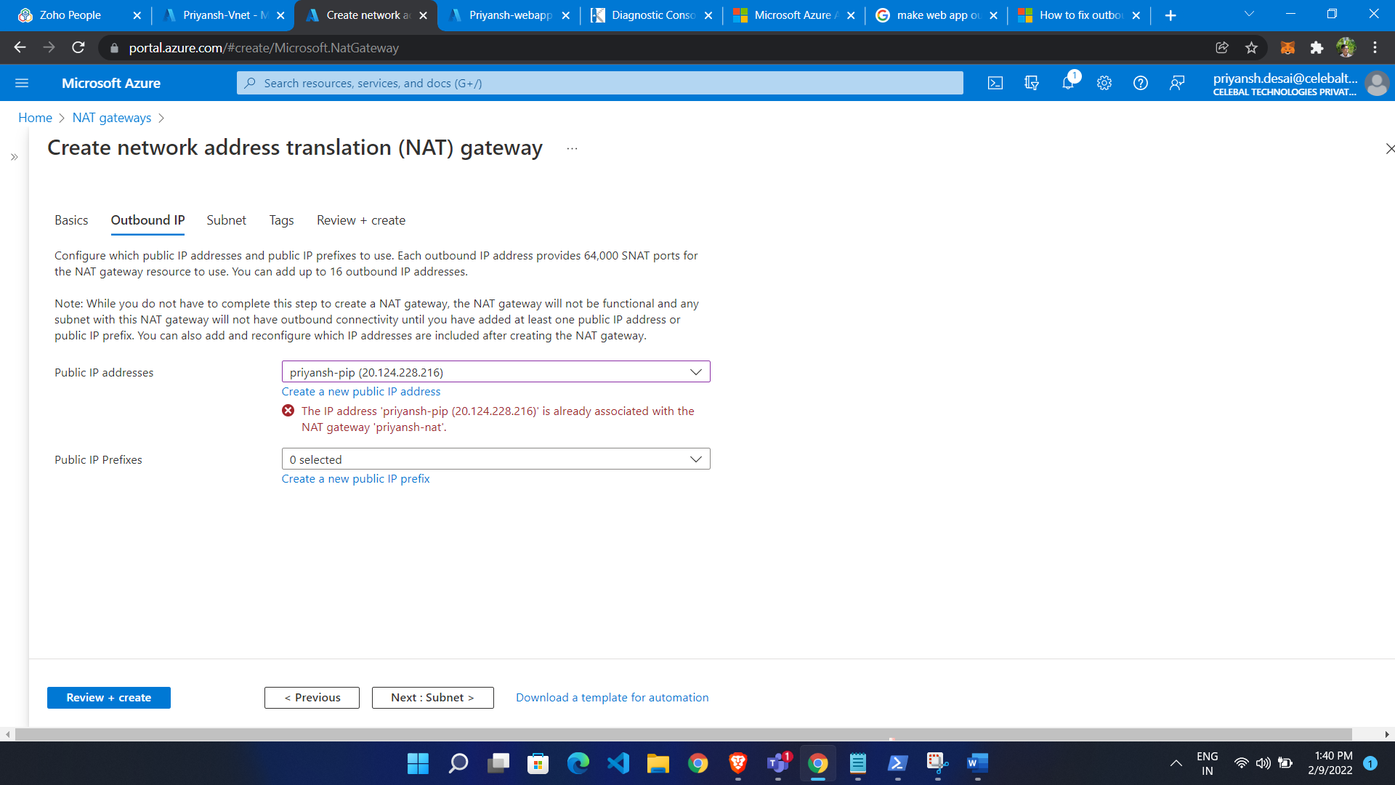

* Choose Vnet and select subnet

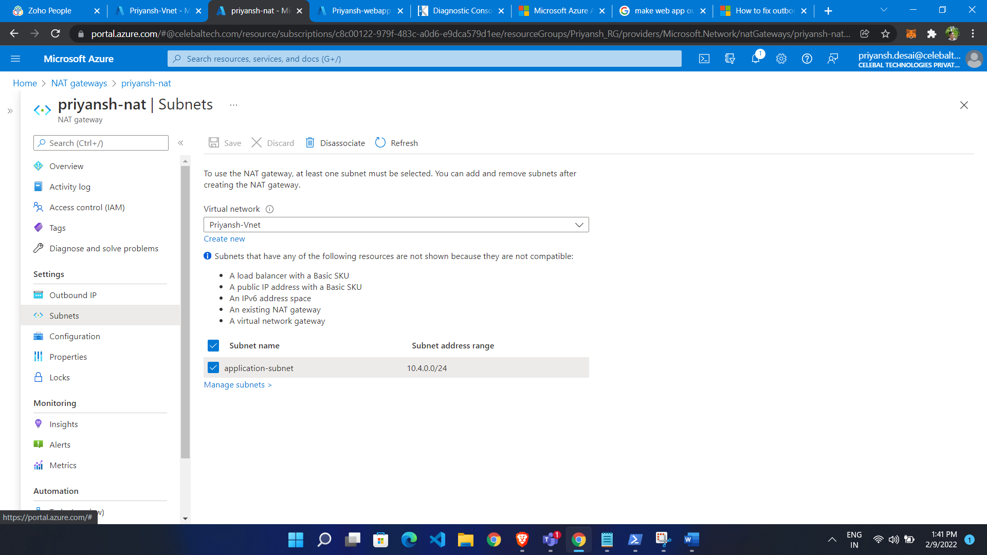

Public Ip of NAT gateway

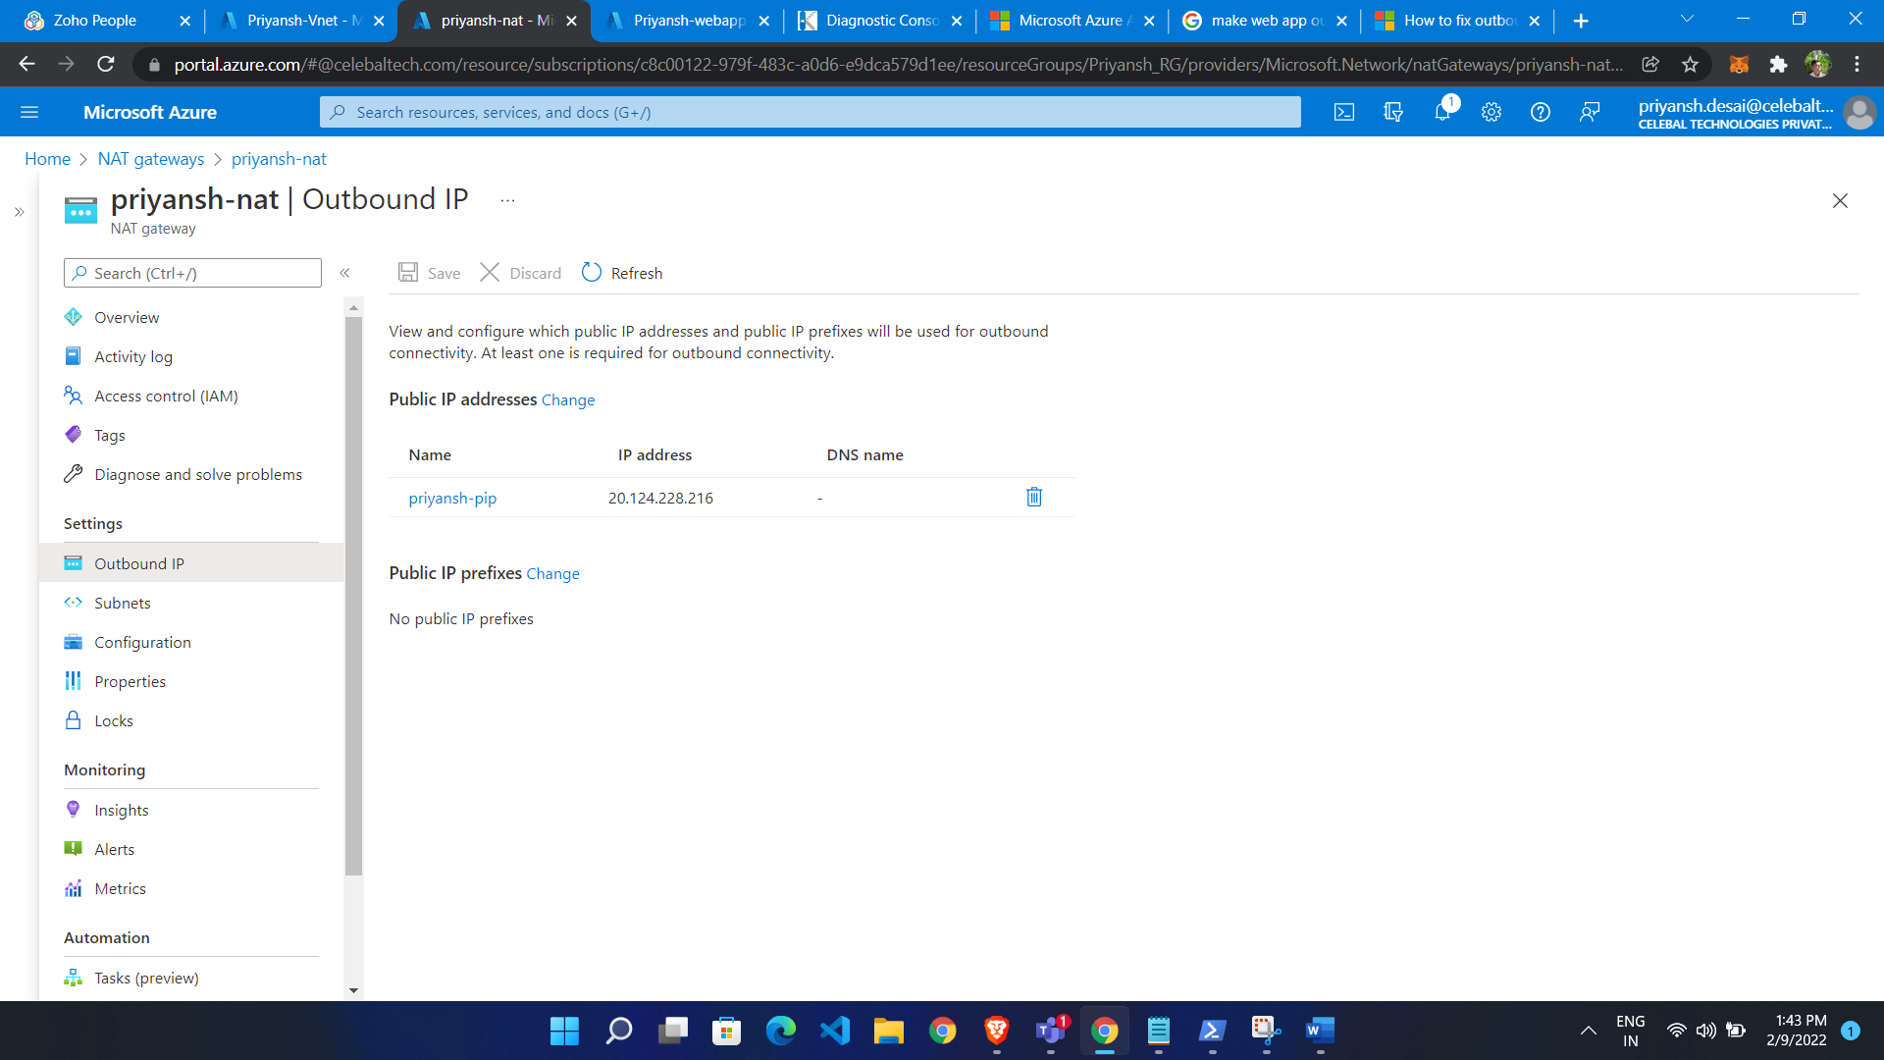

Integrate VNET to web app

* In web app go to networking
* Click go to classic experience
* Click on Vnet integration
* Add vnet there

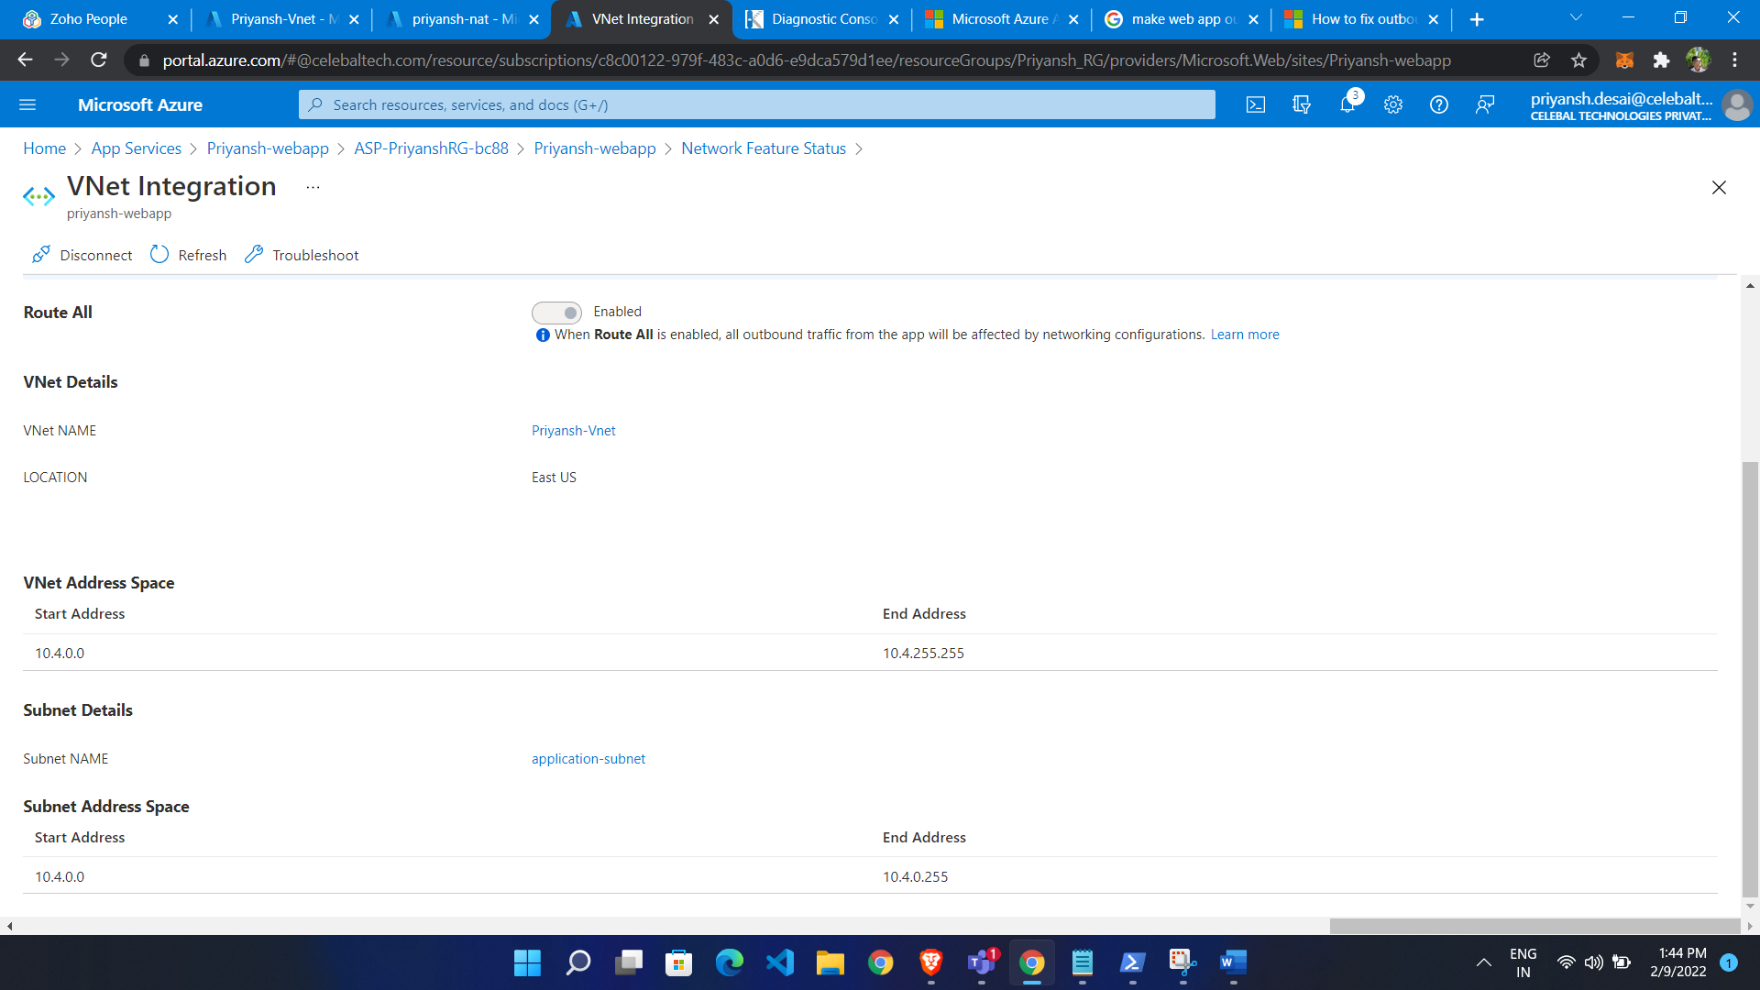

Now Add variable to webapp

* Click configuration from webapp
* Click on add application setting
* Add WEBSITE_VNET_ROUTE_ALL = 1

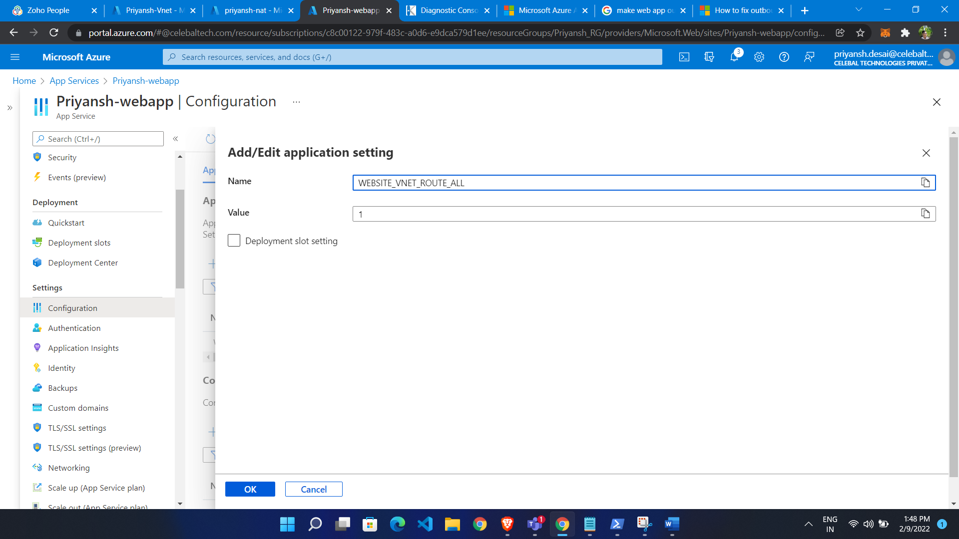

Outbound IP

